[Rain Gardens!](https://michaelbottom.me/client-project-1/" \l "page-top" \t "_blank)

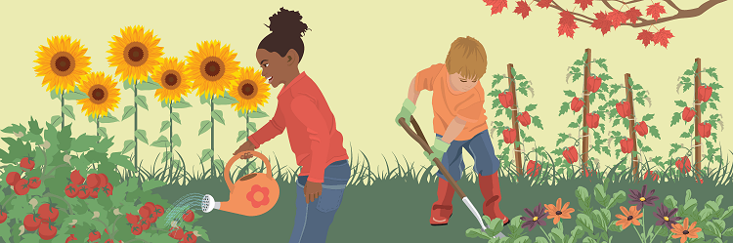

DO YOU KNOW WHAT ONE *LOOKS* LIKE?

*WHAT* IS A RAIN GARDEN?

* Rain gardens are places on the ground for native plants.

* They **capture** extra rain that would run down the street or sidewalk.

* Rain gardens **absorb** a few inches of water every time it rains.

* They **conserve** water too so you don't need to water a lawn every few days!

* Rain gardens can be **very colorful** and popular.

 

* It's best when at least 10 feet away from buildings.

* They are happiest in part or full sunlight.

* The soil in them can be sandy, clay, or mixed!

* They can be various different shapes or sizes, just like puppies and cake!

HOW RAIN GARDENS *HELP* US

* They keep water from pooling nearby and causing damage to your **home**.

* They prevent **toxic water** from running into the sewers, ponds, and lakes.

* They reduce the chances of mosquitoes and other pests from hanging around puddles of water.

* They **help** native plants stay around and continue growing.
* Rain gardens keep the soil from **drying out** and breaking apart.

* Air moisture stays more regular with them around which helps clouds form.

* All these **positive** things would help a lot of people in your city.

* And a **better environment** and happier neighbors means more time to play!

